Computer Architecture
Homework 10
Theme: RISC
All questions are weighted equally. You must show your work.

- In a tabular form, explain the differences between RISC and CISC architectures.
CISC | RISC
Emphasis on hardware | Emphasis on software
Includes multi-clock  complex instructions | Single-clock,  reduced instruction only
Memory-to-memory:  "LOAD" and "STORE"  incorporated in instructions | Register to register:  "LOAD" and "STORE"  are independent instructions
Small code sizes,  high cycles per second | Low cycles per second,  large code sizes
Transistors used for storing  complex instructions | Spends more transistors  on memory registers

- What is the rationale of using a register window system? How are global variables stored in RISC? Discuss the pros and cons of using a large register file vs. a large cache.
  - Using a register window is a technique to improve the performance of a particularly common operation, the procedure call.
  - The window scheme just described provides an efficient organization for storing local scalar variables in registers. However, this scheme does not address the need to store global variables, those accessed by more than one procedure. Two options suggest themselves. First, variables declared as global in an HLL can be assigned memory locations by the compiler, and all machine instructions that reference these variables will use memory-reference operands. This is straightforward, from both the hardware and software (compiler) points of view. However, for frequently accessed global variables, this scheme is inefficient.
An alternative is to incorporate a set of global registers in the processor. These registers would be fixed in number and available to all procedures. A unified num- bering scheme can be used to simplify the instruction format. For example, refer- ences to registers 0 through 7 could refer to unique global registers, and references to registers 8 through 31 could be offset to refer to physical registers in the current window. There is an increased hardware burden to accommodate the split in regis- ter addressing. In addition, the linker must decide which global variables should be assigned to registers.
  - The register file, organized into windows, acts as a small, fast buffer for holding a subset of all variables that are likely to be used the most heavily. From this point of view, the register file acts much like a cache memory, although a much faster memory. The question therefore arises as to whether it would be simpler and better to use a cache and a small traditional register file.
Table 15.5 compares characteristics of the two approaches. The window-based register file holds all the local scalar variables (except in the rare case of window overflow) of the most recent N - 1 procedure activations. The cache holds a selec- tion of recently used scalar variables. The register file should save time, because all local scalar variables are retained. On the other hand, the cache may make more effi- cient use of space, because it is reacting to the situation dynamically. Furthermore, caches generally treat all memory references alike, including instructions and other types of data. Thus, savings in these other areas are possible with a cache and not a register file.
A register file may make inefficient use of space, because not all procedures will need the full window space allotted to them. On the other hand, the cache suffers from another sort of inefficiency: Data are read into the cache in blocks. Whereas the register file contains only those variables in use, the cache reads in a block of data, some or much of which will not be used.
The cache is capable of handling global as well as local variables. There are usually many global scalars, but only a few of them are heavily used [KATE83]. A cache will dynamically discover these variables and hold them. If the window- based register file is supplemented with global registers, it too can hold some global scalars. However, when program modules are separately compiled, it is impossible for the compiler to assign global values to registers; the linker must perform this task.
With the register file, the movement of data between registers and memory is determined by the procedure nesting depth. Because this depth usually fluctu- ates within a narrow range, the use of memory is relatively infrequent. Most cache memories are set associative with a small set size. Thus, there is the danger that other data or instructions will compete for cache residency.
Based on the discussion so far, the choice between a large window-based reg- ister file and a cache is not clear-cut. There is one characteristic, however, in which the register approach is clearly superior and which suggests that a cache-based sys- tem will be noticeably slower. This distinction shows up in the amount of addressing overhead experienced by the two approaches.
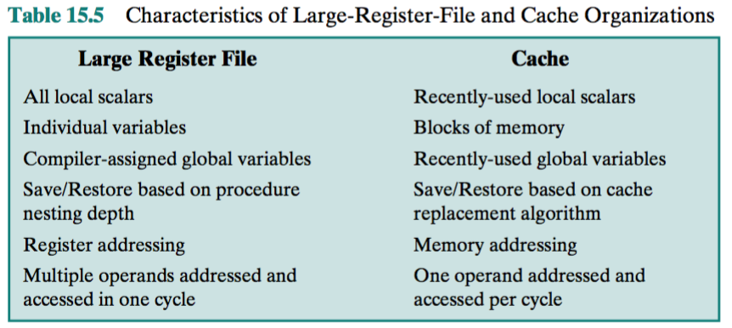
- In a tabular form give the percentage frequency of dynamic occurrence of the most frequently occurring instructions.
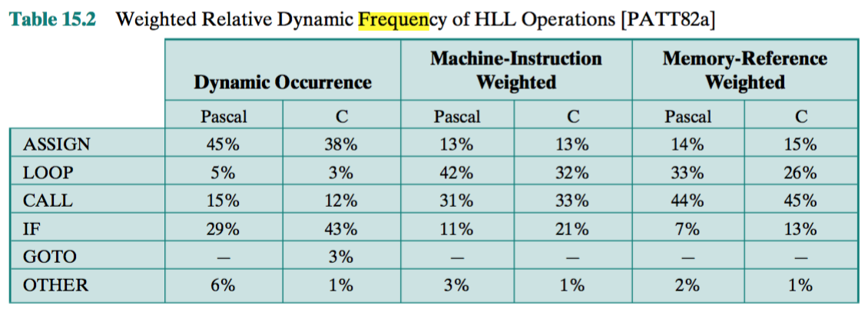

- Considering the call-return pattern in Figure 4.20, how many overflows and underflows (each of which causes a register save/restore) will occur with a window size of: 4, 7, and 16?
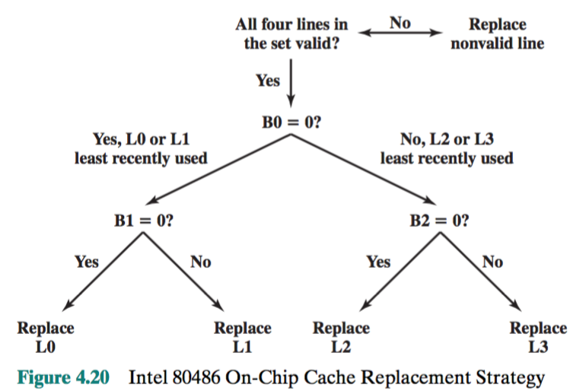

- In the discussion of Figure 15.2, it was stated that only the first two portions of a window are saved or restored. Why is it not necessary to save the temporary registers?
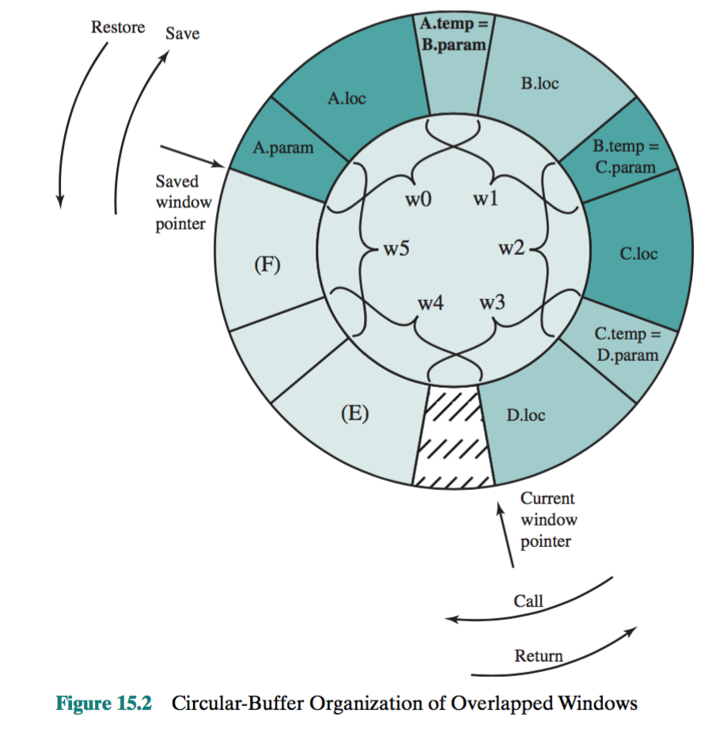
Temporary registers are used to exchange parameters and results with the next lower level (procedure called by current procedure). The temporary registers at one level are physically the same as the parameter registers at the next lower level. This overlap permits parameters to be passed without the actual movement of data. Keep in mind that, except for the overlap, the registers at two different levels are physically distinct. That is, the parameter and local registers at level J are disjoint from the local and temporary registers at level J + 1.

- Using an example, explain the use and function of a register interference graph.
  - The graph-coloring problem is this. Given a graph consisting of nodes and edges, assign colors to nodes such that adjacent nodes have different colors, and do this in such a way as to minimize the number of different colors. This problem is adapted to the compiler problem in the following way. First, the program is ana- lyzed to build a register interference graph. The nodes of the graph are the symbolic registers. If two symbolic registers are “live” during the same program fragment, then they are joined by an edge to depict interference. An attempt is then made to color the graph with n colors, where n is the number of registers. Nodes that share the same color can be assigned to the same register. If this process does not fully succeed, then those nodes that cannot be colored must be placed in memory, and loads and stores must be used to make space for the affected quantities when they are needed.
Figure 15.4 is a simple example of the process. Assume a program with six symbolic registers to be compiled into three actual registers. Figure 15.4a shows the time sequence of active use of each symbolic register. The dashed horizontal lines indicate successive instruction executions. Figure 15.4b shows the register interference graph (shading and cross-hatching are used instead of colors). A possible coloring with three colors is indicated. Because symbolic registers A and D do not interfere, the compile can assign both of these to physical register R1. Similarly, symbolic registers C and E can be assigned to register R3. One symbolic register, F, is left uncolored and must be dealt with using loads and stores.
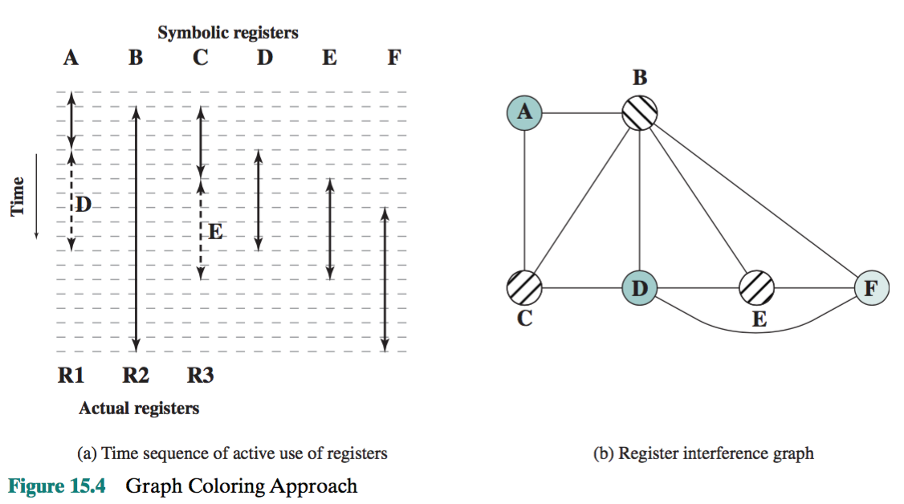

- Using a timing diagram explain the use of delayed branches. Explain the use of reversed instructions.
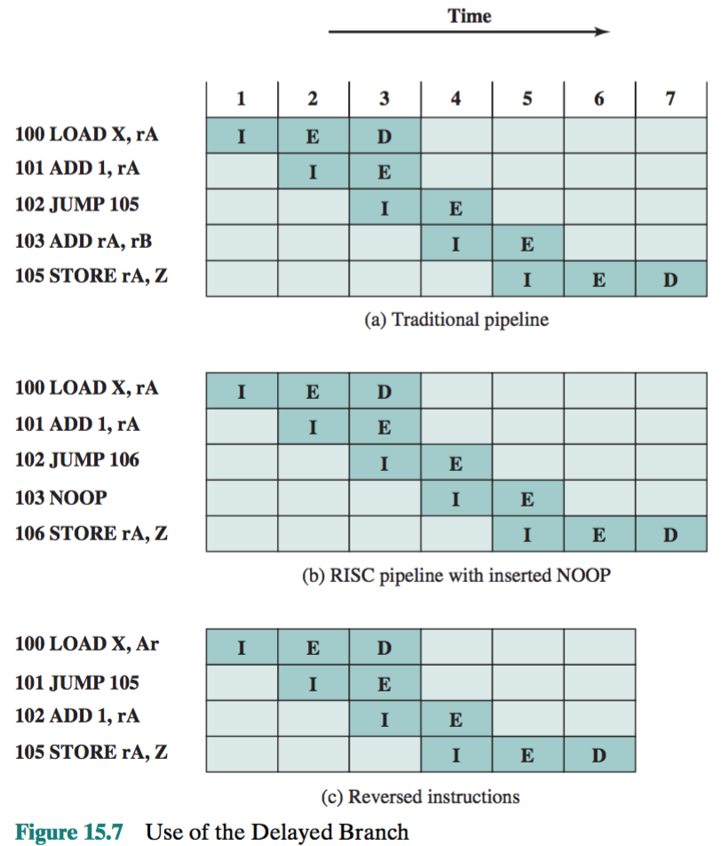
DELAYED BRANCH To compensate for these dependencies, code reorganization techniques have been developed. First, let us consider branching instructions. Delayed branch, a way of increasing the efficiency of the pipeline, makes use of a branch that does not take effect until after execution of the following instruction (hence the term delayed). The instruction location immediately following the branch is referred to as the delay slot. This strange procedure is illustrated in Table 15.8. In the column labeled “normal branch,” we see a normal symbolic instruction machine-language program. After 102 is executed, the next instruction to be executed is 105. To regularize the pipeline, a NOOP is inserted after this branch. However, increased performance is achieved if the instructions at 101 and 102 are interchanged.
Figure 15.7 shows the result. Figure 15.7a shows the traditional approach to pipelining, of the type discussed in Chapter 14 (e.g., see Figures 14.11 and 14.12). The JUMP instruction is fetched at time 3. At time 4, the JUMP instruction is exe- cuted at the same time that instruction 103 (ADD instruction) is fetched. Because a JUMP occurs, which updates the program counter, the pipeline must be cleared of instruction 103; at time 5, instruction 105, which is the target of the JUMP, is loaded. Figure 15.7b shows the same pipeline handled by a typical RISC organization. The timing is the same. However, because of the insertion of the NOOP instruction, we do not need special circuitry to clear the pipeline; the NOOP simply executes with no effect. Figure 15.7c shows the use of the delayed branch. The JUMP instruction is fetched at time 2, before the ADD instruction, which is fetched at time 3. Note, however, that the ADD instruction is fetched before the execution of the JUMP instruction has a chance to alter the program counter. Therefore, during time 4, the ADD instruction is executed at the same time that instruction 105 is fetched.

The timing is the same. However, because of the insertion of the NOOP instruction, we do not need special circuitry to clear the pipeline; the NOOP simply executes with no effect. Figure 15.7c shows the use of the delayed branch. The JUMP instruction is fetched at time 2, before the ADD instruction, which is fetched at time 3. Note, however, that the ADD instruction is fetched before the execution of the JUMP instruction has a chance to alter the program counter. Therefore, during time 4, the ADD instruction is executed at the same time that instruction 105 is fetched. Thus, the original semantics of the program are retained but one less clock cycle is required for execution.

